Ear Dimensions & Weight HIPS 2022

* Turn on the scale by press & holding the Zero button on the scale
* Open programs (located on the desktop) to run in the background as you collect data
  + Winwedge – OHAUS_Scale_Carriage_Return_HIPS
  + Vmux LITE
    - The program needs a moment to recognize the dongle, but you can work on below while it ‘finds it’ 😊

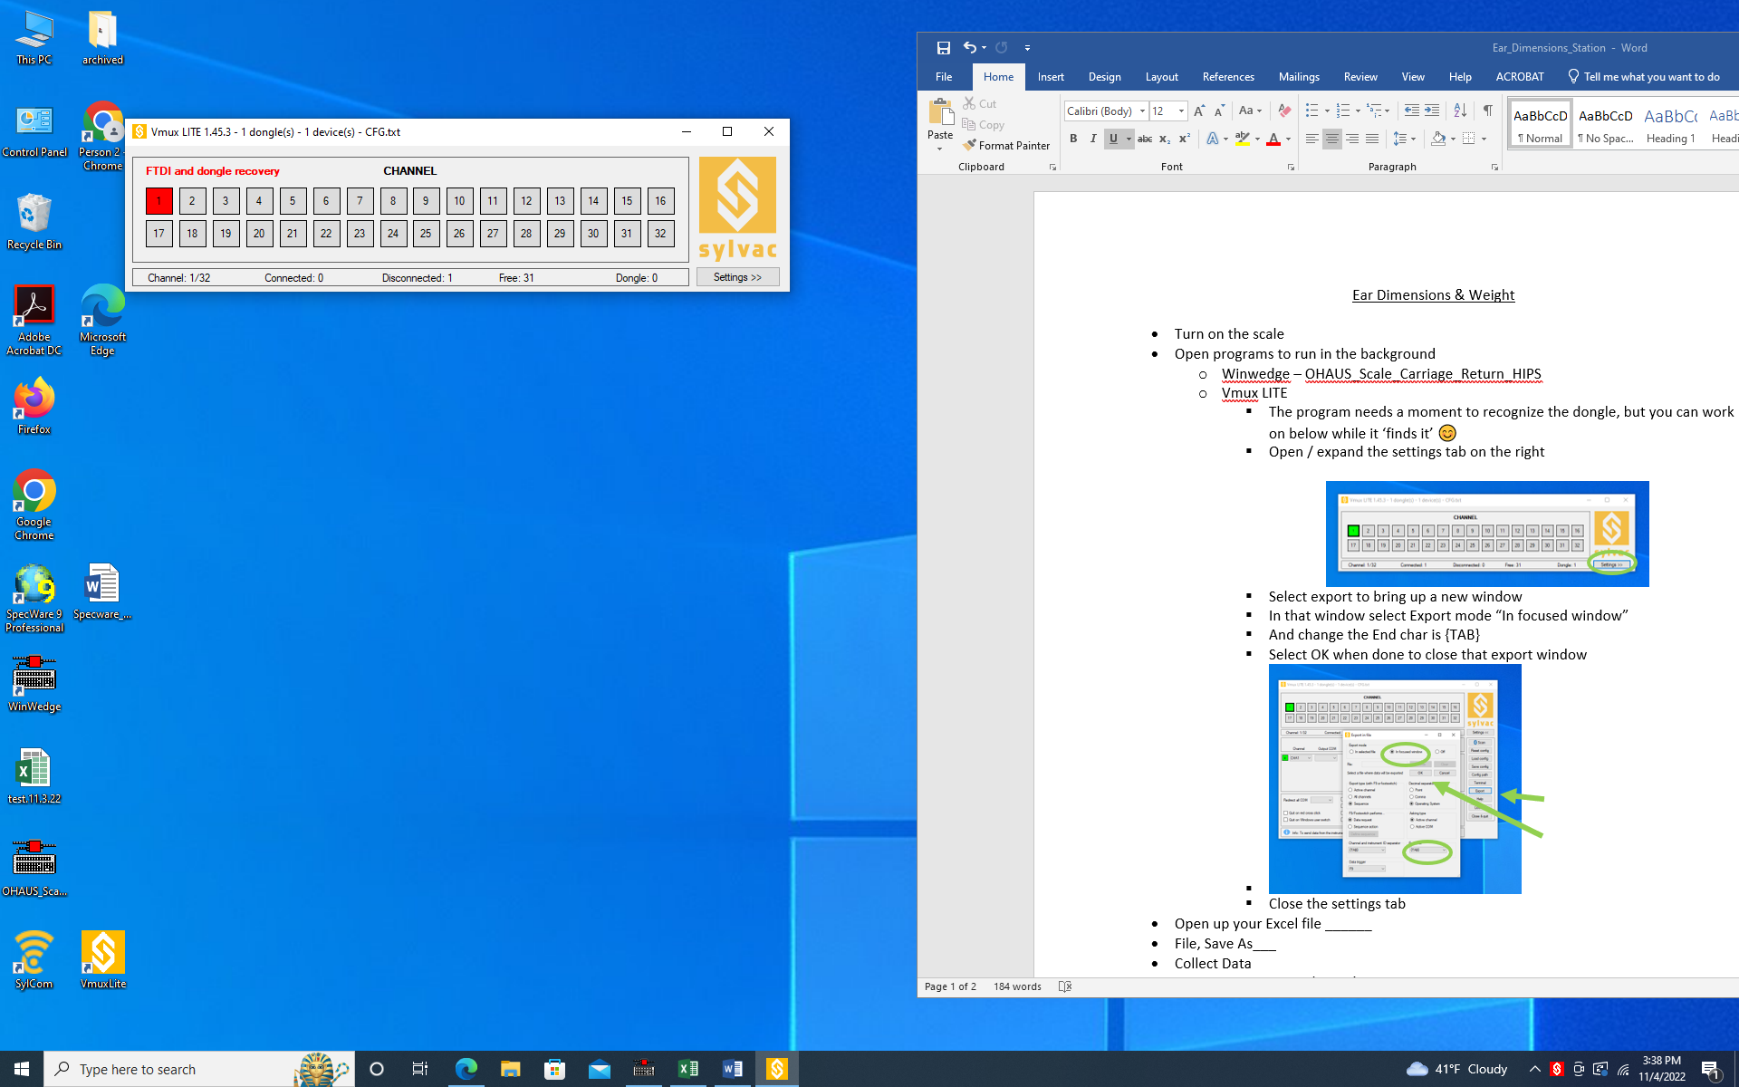

* + - Much of this should be saved in the Vmux program, so you can likely ‘ignore it’ (hence greyed out). But it’s here should you find problems at start of shift
    - Open / expand the settings tab on the right

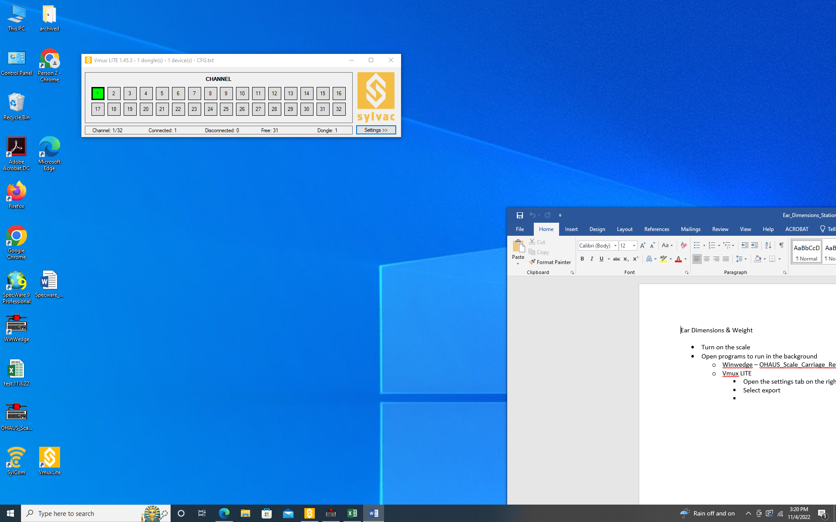

* + - Select export to bring up a new window
    - In that window select Export mode “In focused window”
    - And change the End char is {TAB}
    - Select OK when done to close that export window
    - 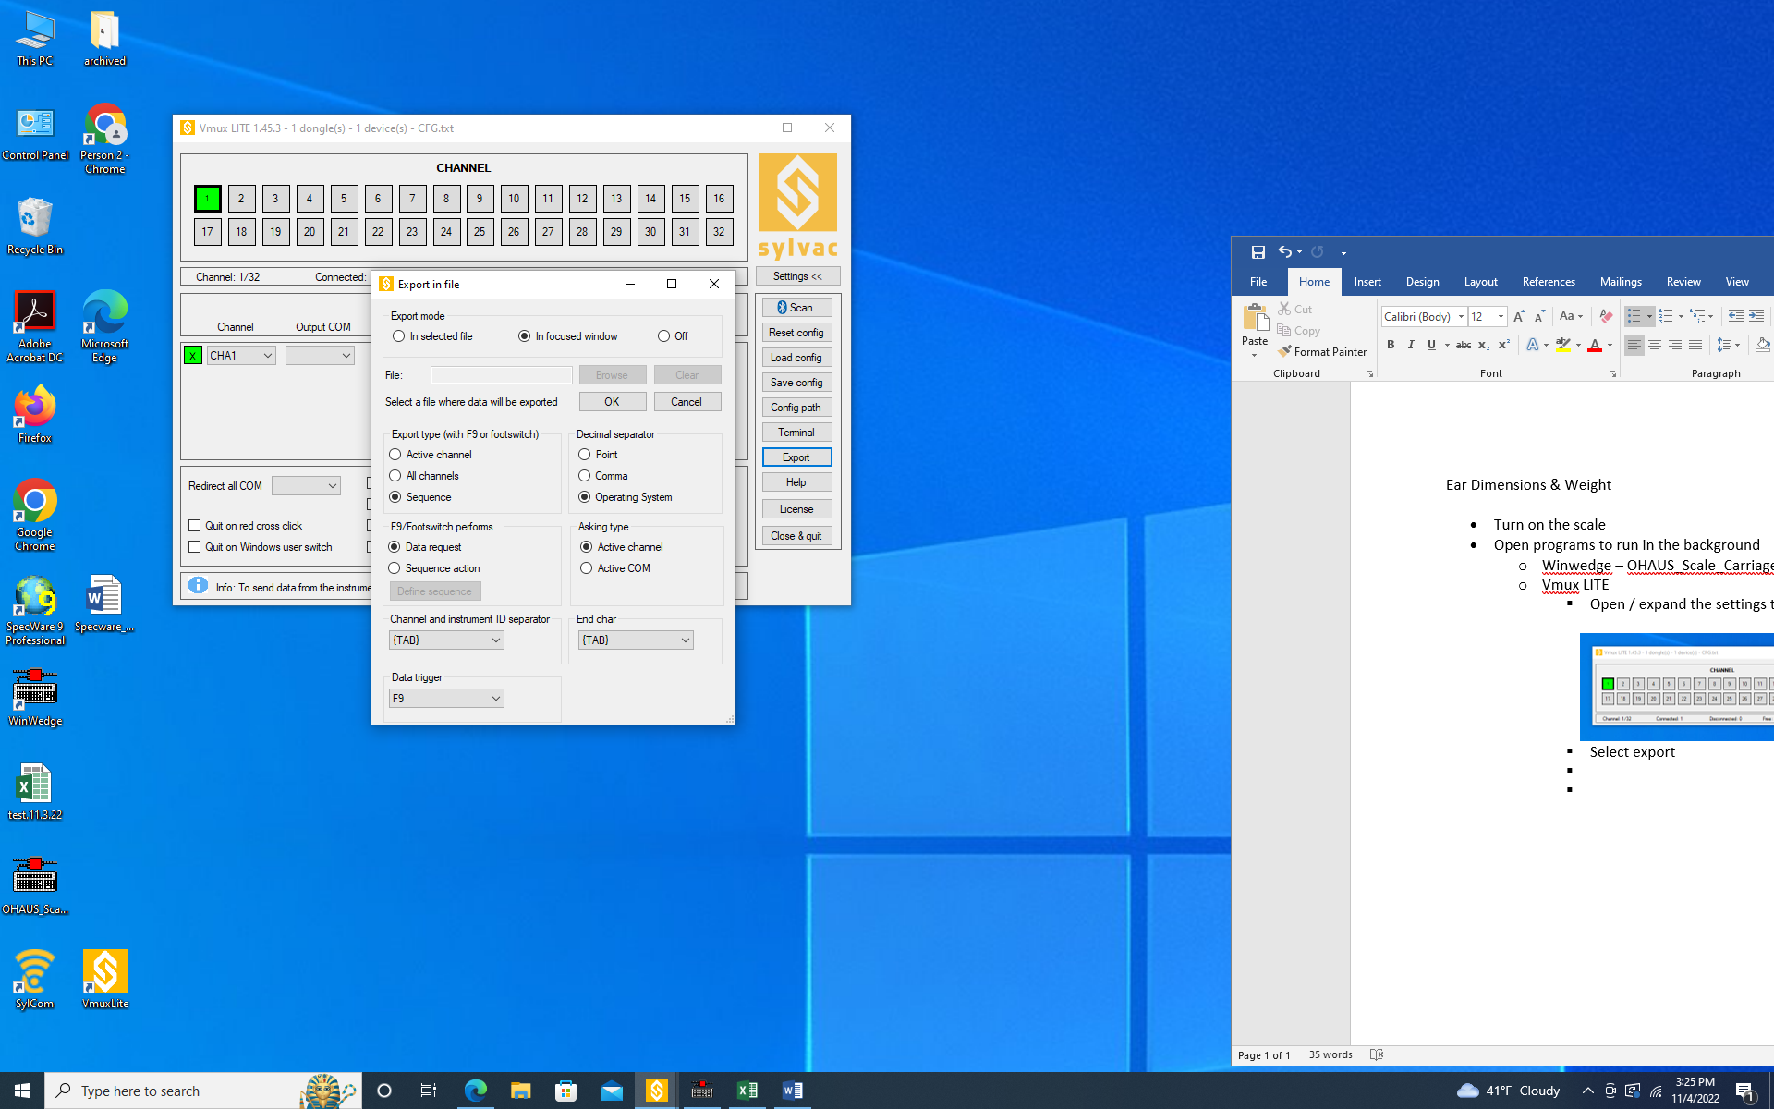
    - Close the settings tab
* From Box, open up your Excel file: 3_Ear_Traits_TEMPLATE.xlsx
* “Save As” & replace TEMPLATE with date & initials
  + example 3_Ear_Traits 11.04.22_lc
* Record if you’re sitting at the left or right station in column E
* Collect Data
  + During you shift
    - Save periodically
    - Make sure that the
      * Scale
        + The scale is in g
        + The scale is tared out (ie the scale reads 0)
        + If you need to tare out the scale, just press and hold the Tare button
      * Caliper
        + The caliper is in mm
        + The caliper reads as 0 when the slider is closed
        + The Bluetooth icon is showing on the top right of the digital screen of the caliper
        + If you have a shift of > 3 hours, clean the caliper with compressed air by sliding the caliper back and forth and blowing the air (do NOT use any rubbing alcohol to clean)
        + See section below about the Caliper if you need help with the above bullet points
  + Remove the ears from one divider of the box
    - Remove any shanks still present using needle nose pliers
    - Determine if any ears need to use the string to measure ear length (see lower point on this)
  + Scan your ear barcode
  + Collect your ear length
  + If your cob is curved
    - use string to measure to run the length of the cob
    - lay the string down on the table and use the caliper to measure the points you marked
    - note on the file that you used the string to obtain length
  + Collect your ear width at the widest part of the ear – typically the lower 1/3 of your ear
  + REMOVE the tag & rubberband & place the ear on the scale and press “Print”
  + The devices & scanner are programmed to move to where you need them next
    - The scanner is programmed to tab over after scanning
    - The Vmux LITE is programmed to tab over for you transmit data
    - The Scale’s winwedge is programmed to carriage return to the 1st column and the next Excel row below ie ready for you to scan the next barcode
* End of shift
  + Save and close the data collection file
  + Sweep off the desk from the seeds and bits of cob
  + Turn off scale by press and holding the Zero button
  + Caliper
    - * Carefully* clean off the caliper with compressed air – avoid the cold condensation build up
    - Close the caliper & tighten the locking screw at the top
    - Press & hold the set button for > 6 seconds
    - Place caliper in its protective box
  + Close the Vmux LITE & Windwedge programs
  + Log out of Box 😊

(Below was copied from Word Doc Caliper_Sylvac_Bluetooth)

**Caliper Sylvac Bluetooth**

Short press vs Hold press

Turn on:

* Unlock screw at the top and move the measure slider

Turn off:

* Close the slider
* Tighten the locking screw on top (this will help to avoid accidental turn on and battery drain)
* Press & hold set button for >6 seconds

***Remember, if you get in the settings and need out, press the data button on top right to exit out

Start of shift:

* Make sure units are in mm (see section below about how to change if needed)
* Make sure caliper measures 0 when slider is closed
* Make sure the Bluetooth icon is showing on the top right of digital screen of the caliper
  + If it doesn’t show, you need to go into settings to turn it on (see next)
  + Turn on Bluetooth: Press mode 3x so it says ‘bt’, press set to toggle until it says ‘on’

How to reset 0

* Close the slider
* Press mode, Press set (both short presses)

How to change units to mm

* Press & hold mode for over 1 second, screen will show ‘Unit’
  + If you accidentally press mode again, it will move to Bluetooth Configurtion (bt.CFG) settings.
  + Just press mode again to toggle back to ‘unit’. Or wait for it to time out (few seconds) or press the data button to exit back out
* When screen says ‘Unit’, press Set
* Press Set to toggle between mm and inches
* Either wait a few seconds, or press the data button to exit out